Software Development Specification

LeatherVerse
Table of Contents
1 Introduction 3
1.1 Purpose of Document 3
1.2 Intended Audience 3
1.3 Document Convention 3
1.4 Project Overview 3
1.5 Scope 4
2 Design Considerations 5
2.1 Assumptions and Dependencies 5
2.2 Risks and Volatile Areas 5
3 System Architecture 6
3.1 System Level Architecture 6
3.2 Software Architecture 6
4 Design Strategy 11
5 Detailed System Design 12
5.1 Database Design 12
5.1.1 ER Diagram 12
5.1.2 Data Dictionary 13
5.1.2.1 Data 1 Error! Bookmark not defined.
5.1.2.2 Data 2 Error! Bookmark not defined.
5.1.2.3 Data n Error! Bookmark not defined.
5.2 Application Design 20
5.2.1 Sequence Diagram 20
5.2.2 State Diagram 25

Introduction

Purpose of Document
The purpose of this Software Development Specification (SDS) document is to provide a detailed design blueprint for the development of an e-commerce web application. It translates the requirements outlined in the Software Requirements Specification (SRS) into a structured design that guides the implementation, testing, and deployment phases. The document specifies the system architecture, software layers, design strategies, and considerations to ensure the system meets functional and non-functional requirements.
The intended audience includes software developers, system architects, quality assurance engineers, project managers, and stakeholders who will use this document to understand the technical design, implement the system, and validate its functionality.

Intended Audience
This document is intended for the following audiences:
- Software Developers: To implement the system based on the design specifications, including frontend, backend, and database components.
- System Architects: To review and refine the architectural design and ensure alignment with technical goals.
- Quality Assurance Engineers: To develop test plans and validate the system against the design specifications.
- Project Managers: To monitor progress, allocate resources, and ensure the design aligns with project timelines and objectives.
- Stakeholders: To understand the technical approach and ensure the design meets business requirements.

Document Convention
This document adheres to the following conventions:
- Font: Arial
- Font Size: 12pt for body text, 14pt for section headings, 16pt for main titles
- Formatting: Bold for headings, italics for emphasis, and tables for structured data. UML diagrams (e.g., component, package, and layered architecture diagrams) will be used to illustrate the system design.

Project Overview
The e-commerce web application is designed to provide a platform for online shopping, enabling customers to browse products, manage carts, complete purchases, and track orders, while administrators manage products and orders. The system will be a web-based application with a React.js frontend for a responsive user interface, an Express.js/Node.js backend for business logic and API services, a MongoDB database for data storage, and Cloudinary for image hosting.
The basic design approach follows a layered architecture, separating the presentation layer (React.js), application layer (Express.js/Node.js), and data layer (MongoDB). This approach ensures modularity, scalability, and maintainability, allowing for independent development and testing of each layer.

Scope
What the System Will Do:
- Enable user registration, login, and profile management.
- Allow users to browse, search, and filter products in a catalog.
- Support shopping cart functionality (add, update, remove items).
- Facilitate checkout with address input and payment processing via PayPal.
- Provide order tracking and history for users.
- Allow administrators to manage products (add, update, delete) and view order details.
- Ensure performance, security, and scalability for handling concurrent users.
What the System Will Not Do:
- Integrate with external logistics APIs for real-time shipping updates.
- Support multi-language or multi-currency features beyond English and USD.
- Provide cryptocurrency payment options.
- Include advanced analytics or recommendation systems in the initial release.

Design Considerations

Assumptions and Dependencies
This section outlines design-specific assumptions and dependencies that were not covered in the SRS:
- Assumptions:
  - The React.js frontend will be compatible with modern browsers (Chrome, Firefox, Safari, Edge) without requiring additional polyfills for older browsers.
  - Cloudinary’s image upload and retrieval services will have minimal latency (<1 second) to ensure smooth product image loading.
  - MongoDB’s document-based structure will handle nested data (e.g., cart items, order details) efficiently without requiring complex joins.
- Dependencies:
  - Availability of Node.js libraries (e.g., Mongoose for MongoDB interaction, Cloudinary SDK for image uploads).
  - PayPal API uptime and reliability for payment processing, as downtime could disrupt checkout functionality.
  - Adequate cloud server resources (e.g., AWS EC2) to handle peak traffic, assuming auto-scaling is configured.

Risks and Volatile Areas
- Risk: Changes in Payment Gateway API
  - PayPal may update its API, requiring changes to the payment integration.
  - Mitigation: Design the payment module as a loosely coupled service, allowing for easy replacement with another gateway (e.g., Stripe) by abstracting the payment logic into a separate module.
- Risk: Scalability Challenges
  - High traffic during sales events may overload the backend or database.
  - Mitigation: Implement caching (e.g., Redis) for frequently accessed data (e.g., product catalog) and use MongoDB indexing to optimize queries. Auto-scaling on the cloud infrastructure will handle traffic spikes.
- Risk: Security Vulnerabilities
  - Potential for XSS or CSRF attacks due to user inputs in forms (e.g., reviews, addresses).
  - Mitigation: Use input sanitization libraries (e.g., DOMPurify) and enforce CSRF tokens for all form submissions.
- Volatile Area: Product Image Storage
  - Cloudinary’s pricing or service changes could impact image storage costs or availability.
  - Mitigation: Design the image storage module to support multiple providers (e.g., AWS S3 as a fallback) by abstracting the upload logic into a configurable service.

System Architecture

System Level Architecture
The e-commerce web application follows a layered architecture with clear separation of concerns, decomposed into the following major components:
- Frontend (React.js): Handles the user interface, client-side logic, and API requests.
- Backend (Express.js/Node.js): Manages business logic, API endpoints, and interactions with the database and external services.
- Database (MongoDB): Stores user data, products, carts, orders, and reviews.
- External Services:
  - Cloudinary for image storage and retrieval.
  - PayPal for payment processing.
Relationships Between Elements:
- The Frontend communicates with the Backend via RESTful APIs over HTTPS.
- The Backend interacts with MongoDB using Mongoose for data operations.
- The Backend uploads product images to Cloudinary and retrieves URLs for storage in MongoDB.
- The Backend integrates with PayPal for payment processing during checkout.
Interfaces to External Systems:
- Cloudinary API: Used for uploading and retrieving product images (HTTP POST/GET).
- PayPal API: Used for payment initiation and confirmation (HTTP POST/GET with JSON payloads).
Major Physical Design Issues:
- The Frontend will be hosted on a CDN (e.g., Netlify) for faster load times.
- The Backend will run on a cloud server (e.g., AWS EC2) with auto-scaling enabled to handle traffic spikes.
- MongoDB will be hosted on a managed service (e.g., MongoDB Atlas) for reliability and backups.
Global Design Strategies:
- Error Handling: All API responses will include standardized error codes (e.g., 400 for bad requests, 500 for server errors) and user-friendly messages. Errors will be logged using a logging framework (e.g., Winston).
- Security: HTTPS will be enforced for all communications, and JWT tokens will secure user sessions.
UML Component Diagram (Conceptual):
- Components: Frontend, Backend, MongoDB, Cloudinary, PayPal
- Connections:
  - Frontend → Backend (REST API over HTTPS)
  - Backend → MongoDB (Mongoose queries)
  - Backend → Cloudinary (HTTP POST for image uploads)
  - Backend → PayPal (HTTP POST for payment processing)

Software Architecture
The software architecture is structured into three layers:
- User Interface Layer (React.js):
  - Responsible for rendering the UI, handling user interactions, and making API calls to the Backend.
  - Uses React Router for navigation and Redux for state management (e.g., cart state).
- Middle Tier (Express.js/Node.js):
  - Handles business logic, API routing, and request validation.
  - Communicates with MongoDB for data operations and Cloudinary/PayPal for external services.
  - Uses middleware for authentication (e.g., JWT verification) and error handling.
- Data Access Layer (MongoDB):
  - Stores data in a NoSQL database with collections for Users, Products, Carts, Orders, and Reviews.
  - Mongoose is used to define schemas and perform CRUD operations.
- Layer Interaction Diagram (Conceptual):
- Flow:
  - User Interface Layer sends HTTP requests (e.g., GET /api/products) to Middle Tier.
  - Middle Tier processes the request, queries the Data Access Layer (e.g., MongoDB find()), and returns a response.
  - Data Access Layer returns raw data to Middle Tier, which formats it for the User Interface Layer.
- 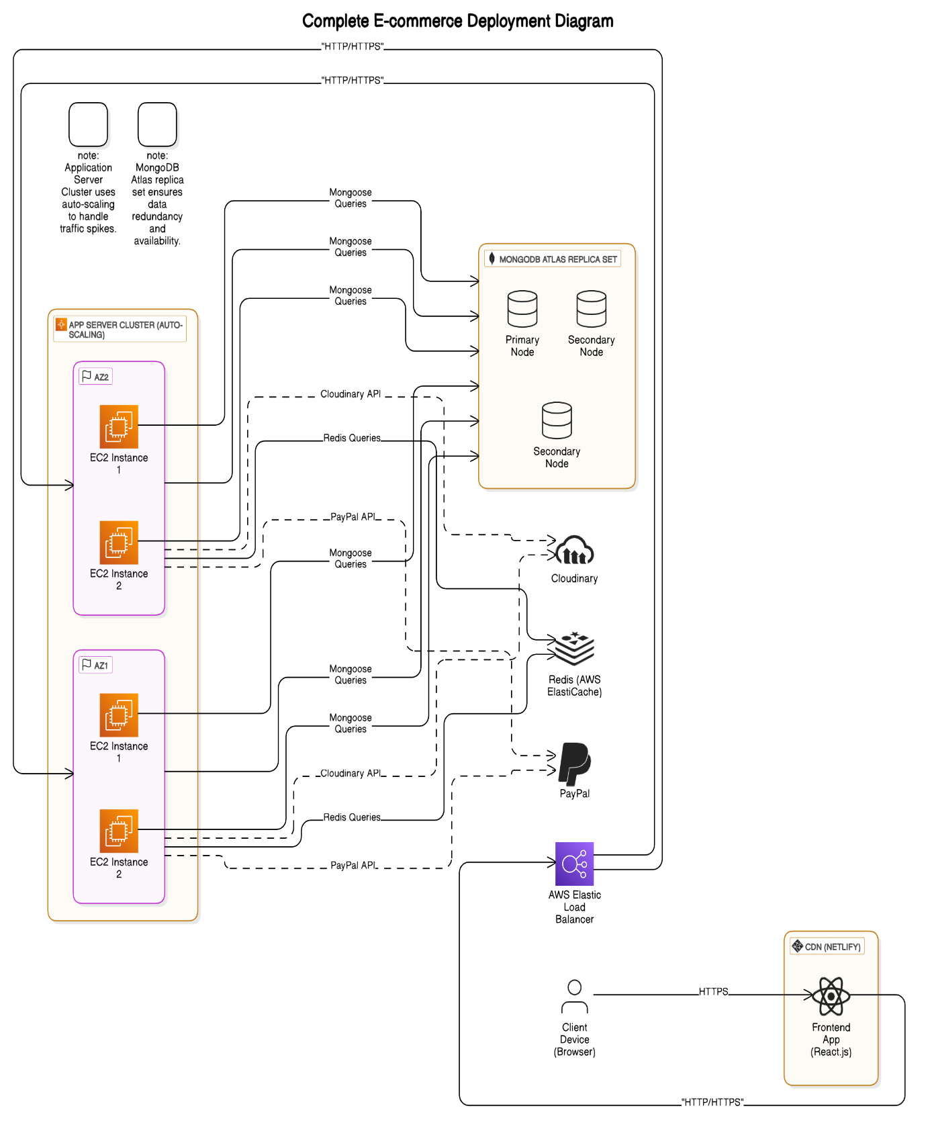

- 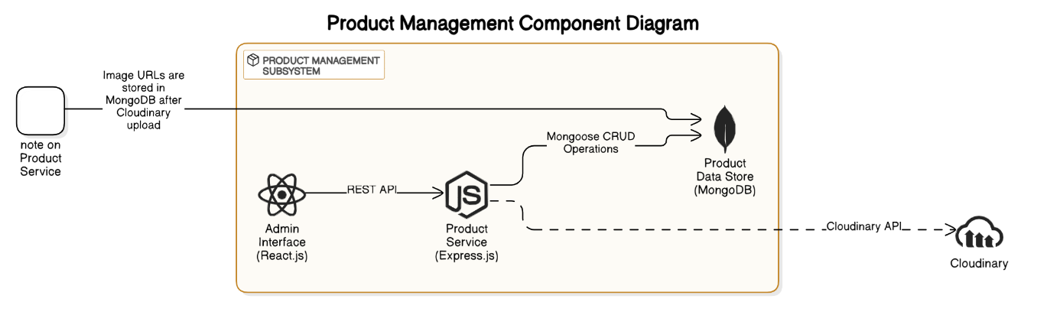

- 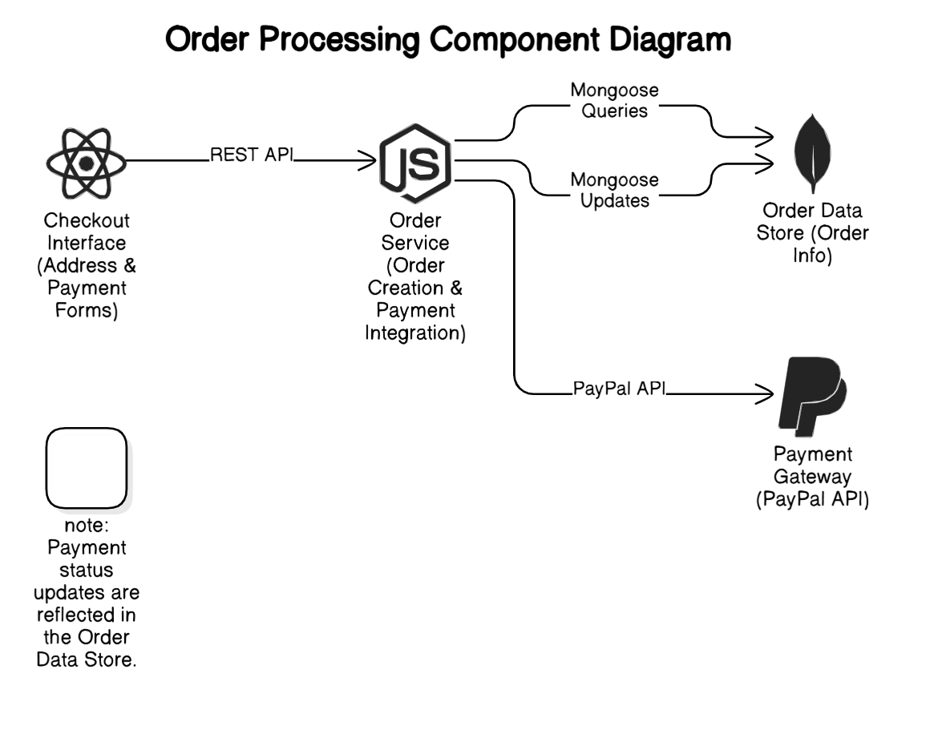

- 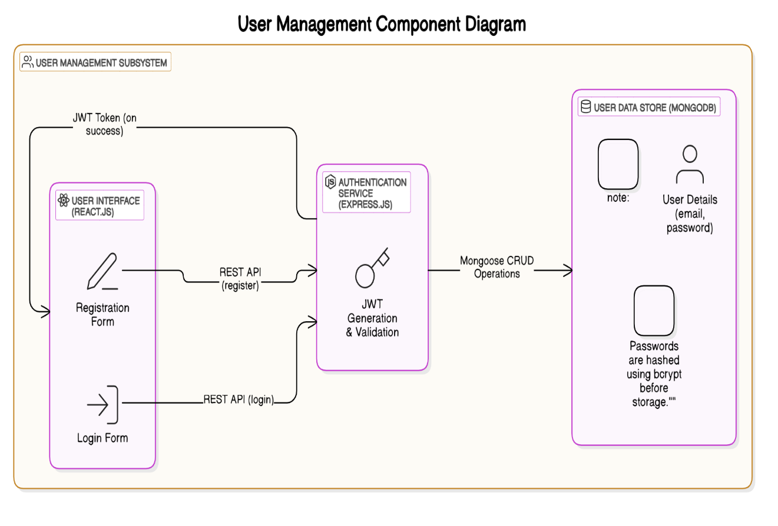

- 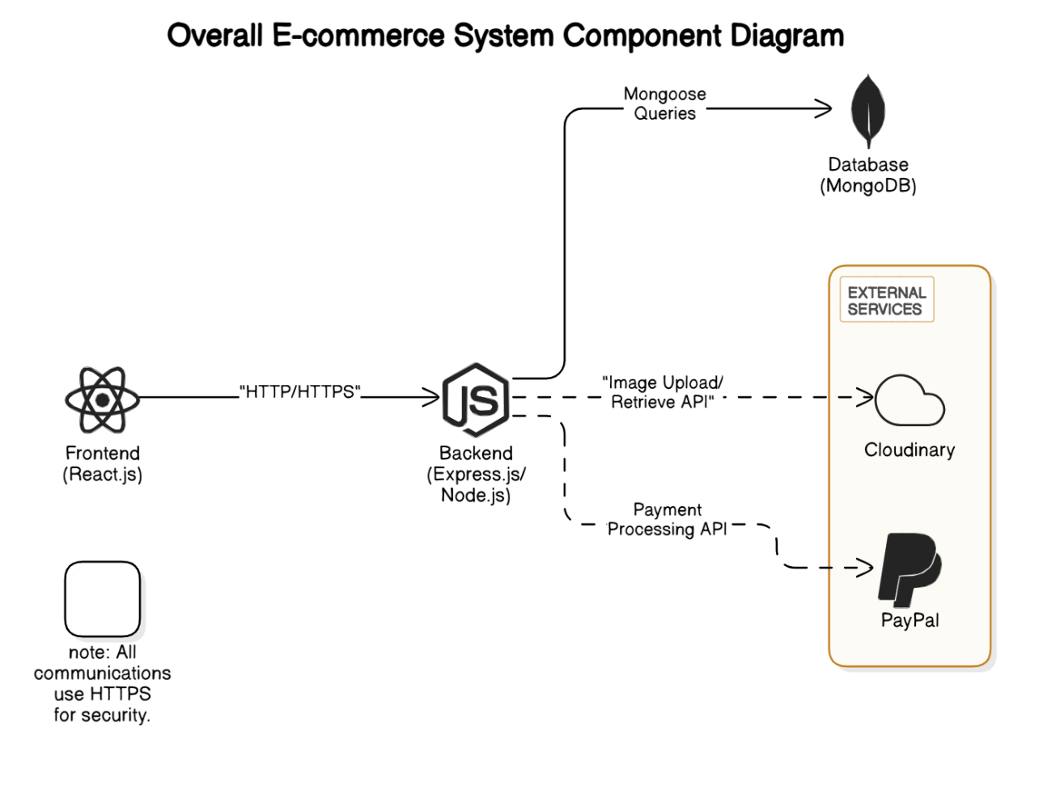

Design Strategy
- Future System Extension or Enhancement
- Modular Design: The system uses a modular architecture with separate components for user management, product catalog, cart, and orders. This allows for easy addition of new features (e.g., product recommendations) by plugging in new modules.
- API-First Approach: All backend functionality is exposed via RESTful APIs, enabling future integration with mobile apps or third-party services.
- Reasoning: Modularity reduces the impact of changes, aligning with the goal of extensibility.
- Trade-off: Initial development may take longer due to the need for well-defined interfaces.
- System Reuse
- Reusable Components: React components (e.g., ProductCard, FormInput) are designed for reuse across pages (e.g., homepage, product listing).
- Backend Services: Common utilities (e.g., authentication middleware, image upload service) are abstracted for reuse across different endpoints.
- Reasoning: Reuse reduces development time and ensures consistency.
- Trade-off: Reusable components may be less optimized for specific use cases.
- User Interface Paradigms
- Responsive Design: The UI follows a mobile-first approach using CSS frameworks (e.g., Tailwind CSS) to ensure compatibility across devices.
- Single Page Application (SPA): React.js enables a seamless SPA experience with client-side routing, reducing page reloads.
- Reasoning: SPAs improve user experience by providing faster navigation, aligning with the goal of usability.
- Trade-off: SPAs may increase initial load time due to JavaScript bundle size.
- Data Management (Storage, Distribution, Persistence)
- Storage: MongoDB is used for its flexibility with unstructured data (e.g., nested cart items). Product images are stored on Cloudinary to offload storage from the database.
- Distribution: Data is distributed across collections (e.g., Users, Products) with appropriate indexes (e.g., on userId) for efficient querying.
- Persistence: Data is persisted in MongoDB with regular backups via MongoDB Atlas. Caching (e.g., Redis) will be used for frequently accessed data like product listings.
- Reasoning: This approach balances performance and scalability while keeping costs manageable.
- Trade-off: MongoDB’s lack of strict schema may lead to data inconsistencies if not carefully managed.
- Concurrency and Synchronization
- Concurrency: The Backend handles concurrent requests using Node.js’s non-blocking I/O model. MongoDB transactions ensure atomic updates (e.g., during checkout).
- Synchronization: WebSocket is used for real-time updates (e.g., order status changes in the admin panel).
- Reasoning: Non-blocking I/O ensures the system can handle multiple users simultaneously, supporting the performance goal.
- Trade-off: WebSocket usage increases server complexity and resource consumption.

5 Detailed System Design

Database Design

ER Diagram
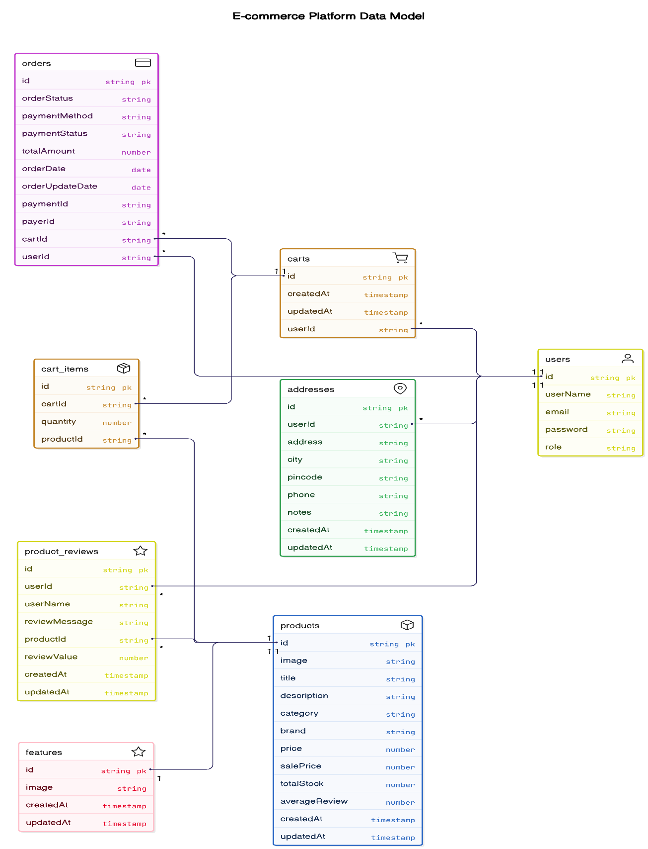

Data Dictionary
5.1.2.1 Address
Name: Address
Alias: User Address, Shipping Address
Where-used/how-used:
- Input to the Checkout Process (used to store shipping details).
- Output from the User Profile (displayed as saved addresses).
- Stored in MongoDB as a collection.
Content Description:
Address = userId + address + city + pincode + phone + notes + {timestamps}
Column Name | Description | Type | Length | Null able | Default Value | Key Type
userId | Unique identifier of the user | String | 24 | No | None | FK
address | Street address of the user | String | 255 | No | None
city | City of the user | String | 100 | No | None
pincode | Postal code of the address | String | 10 | No | None
phone | Contact phone number | String | 15 | No | None
notes | Additional delivery instructions | String | 500 | Yes | None
createdAt | Timestamp of address creation | Date | N/A | No | Current
updatedAt | Timestamp of address update | Date | N/A | No | Current

5.1.2.2 Cart
Name: Cart
Alias: Shopping Cart
Where-used/how-used:
- Input to the Checkout Process (used to retrieve items for purchase).
- Output from the Add to Cart Process (updated cart displayed to user).
- Stored in MongoDB as a collection.
Content Description:
Cart = userId + {items} + {timestamps}
items = productId + quantity
Column Name | Description | Type | Length | Null able | Default Value | Key Type
userId | Unique identifier of the user | ObjectId | 24 | No | None | FK
items | Array of items in the cart | Array | N/A | No | []
items.productId | Unique identifier of the product | ObjectId | 24 | No | None | FK
items.quantity | Number of units of the product | Number | N/A | No | 1
createdAt | Timestamp of cart creation | Date | N/A | No | Current
updatedAt | Timestamp of cart update | Date | N/A | No | Current

5.1.2.3 Feature
Name: Feature
Alias: Featured Image
Where-used/how-used:
- Output from the Homepage Display (used to display promotional images).
- Stored in MongoDB as a collection.
Content Description:
Feature = image + {timestamps}
Column Name | Description | Type | Length | Null able | Default Value | Key Type
image | URL of the featured image | String | 255 | No | None
createdAt | Timestamp of feature creation | Date | N/A | No | Current
updatedAt | Timestamp of feature update | Date | N/A | No | Current

5.1.2.4 Order
Name: Order
Alias: Purchase Order
Where-used/how-used:
- Output from the Checkout Process (created after successful payment).
- Input to the Order Management Process (used to view order details).
- Stored in MongoDB as a collection.
Content Description:
Order = userId + cartId + {cartItems} + addressInfo + orderStatus + paymentMethod + paymentStatus + totalAmount + orderDate + orderUpdateDate + (paymentId) + (payerId)
cartItems = productId + title + image + price + quantity
addressInfo = addressId + address + city + pincode + phone + notes
Column Name | Description | Type | Length | Null able | Default Value | Key Type
userId | Unique identifier of the user | String | 24 | No | None | FK
cartId | Unique identifier of the cart | String | 24 | No | None | FK
cartItems | Array of items in the order | Array | N/A | No | []
cartItems.productId | Unique identifier of the product | String | 24 | No | None | FK
cartItems.title | Title of the product | String | 255 | No | None
cartItems.image | URL of the product image | String | 255 | No | None
cartItems.price | Price of the product | String | 10 | No | None
cartItems.quantity | Number of units ordered | Number | N/A | No | 1
addressInfo | Shipping address details | Object | N/A | No | None
addressInfo.addressId | Unique identifier of the address | String | 24 | No | None | FK
addressInfo.address | Street address | String | 255 | No | None
addressInfo.city | City | String | 100 | No | None
addressInfo.pincode | Postal code | String | 10 | No | None
addressInfo.phone | Contact phone number | String | 15 | No | None
addressInfo.notes | Additional delivery notes | String | 500 | Yes | None
orderStatus | Status of the order | String | 50 | No | "Pending"
paymentMethod | Method of payment | String | 50 | No | None
paymentStatus | Status of the payment | String | 50 | No | "Pending"
totalAmount | Total cost of the order | Number | N/A | No | 0
orderDate | Date of order placement | Date | N/A | No | Current
orderUpdateDate | Date of last order update | Date | N/A | Yes | None
paymentId | Payment transaction ID | String | 50 | Yes | None
payerId | Payer ID from payment gateway | String | 50 | Yes | None

5.1.2.5 Product
Name: Product
Alias: Item, Catalog Item
Where-used/how-used:
- Output from the Product Catalog Process (displayed to users).
- Input to the Add to Cart Process (used to add items to cart).
- Stored in MongoDB as a collection.
Content Description:
Product = image + title + description + category + brand + price + salePrice + totalStock + averageReview + {timestamps}
Column Name | Description | Type | Length | Null able | Default Value | Key Type
image | URL of the product image | String | 255 | No | None
title | Title of the product | String | 255 | No | None
description | Description of the product | String | 1000 | No | None
category | Category of the product | String | 100 | No | None
brand | Brand of the product | String | 100 | No | None
price | Original price of the product | Number | N/A | No | 0
salePrice | Discounted price of the product | Number | N/A | Yes | None
totalStock | Total stock available | Number | N/A | No | 0
averageReview | Average rating of the product | Number | N/A | Yes | 0
createdAt | Timestamp of product creation | Date | N/A | No | Current
updatedAt | Timestamp of product update | Date | N/A | No | Current

5.1.2.6 ProductReview
Name: ProductReview
Alias: Review, User Review
Where-used/how-used:
- Input to the Product Details Process (used to display reviews).
- Output from the Submit Review Process (stored after user submission).
- Stored in MongoDB as a collection.
Content Description:
ProductReview = productId + userId + userName + reviewMessage + reviewValue + {timestamps}
Column Name | Description | Type | Length | Null able | Default Value | Key Type
productId | Unique identifier of the product | String | 24 | No | None | FK
userId | Unique identifier of the user | String | 24 | No | None | FK
userName | Name of the user leaving review | String | 100 | No | None
reviewMessage | Text content of the review | String | 1000 | No | None
reviewValue | Rating given by the user (1-5) | Number | N/A | No | 0
createdAt | Timestamp of review creation | Date | N/A | No | Current
updatedAt | Timestamp of review update | Date | N/A | No | Current

5.1.2.7 User
Name: User
Alias: Account, Customer Profile
Where-used/how-used:
- Input to the Login Process (used for authentication).
- Output from the Registration Process (created upon signup).
- Stored in MongoDB as a collection.
Content Description:
User = userName + email + password + role
Column Name | Description | Type | Length | Null able | Default Value | Key Type
userName | Unique username of the user | String | 100 | No | None
email | Unique email address of the user | String | 255 | No | None
password | Hashed password of the user | String | 255 | No | None
role | Role of the user (user/admin) | String | 50 | No | "user"

Application Design

Sequence Diagram

User Registration
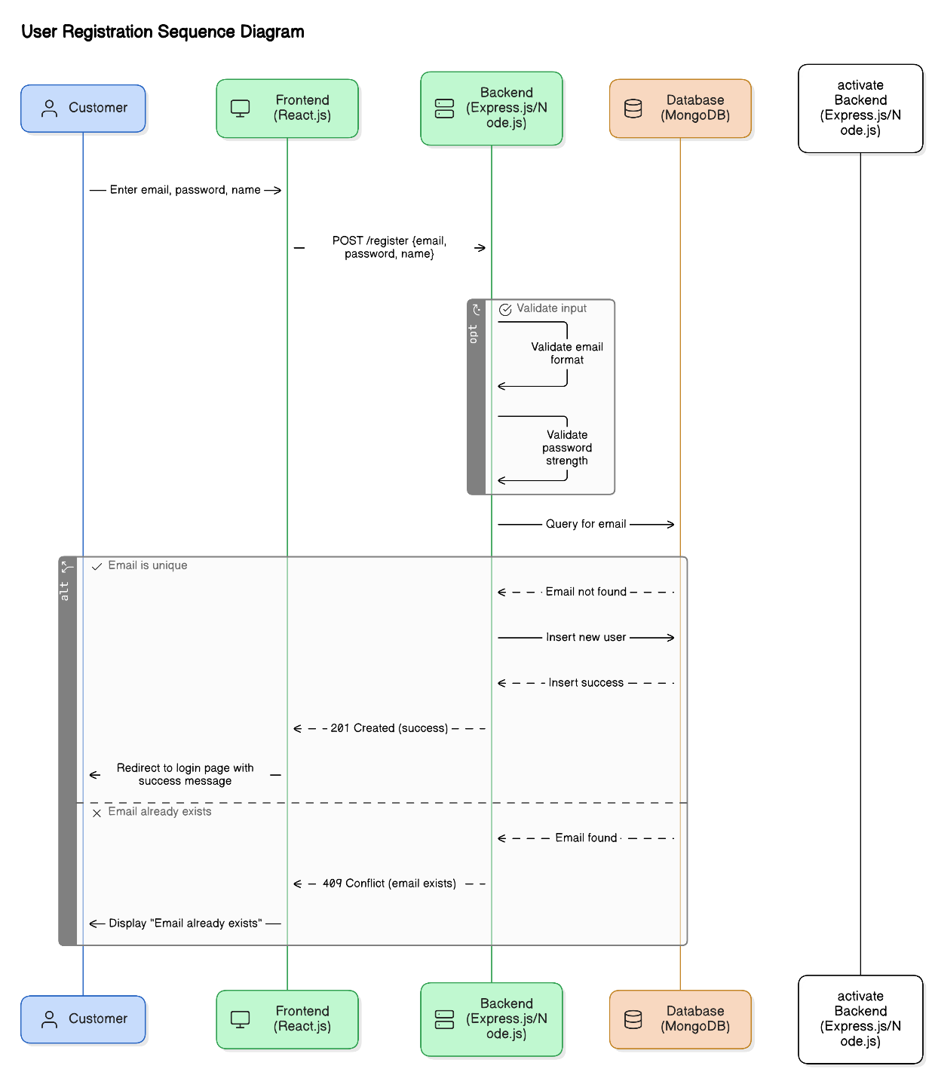

User Login
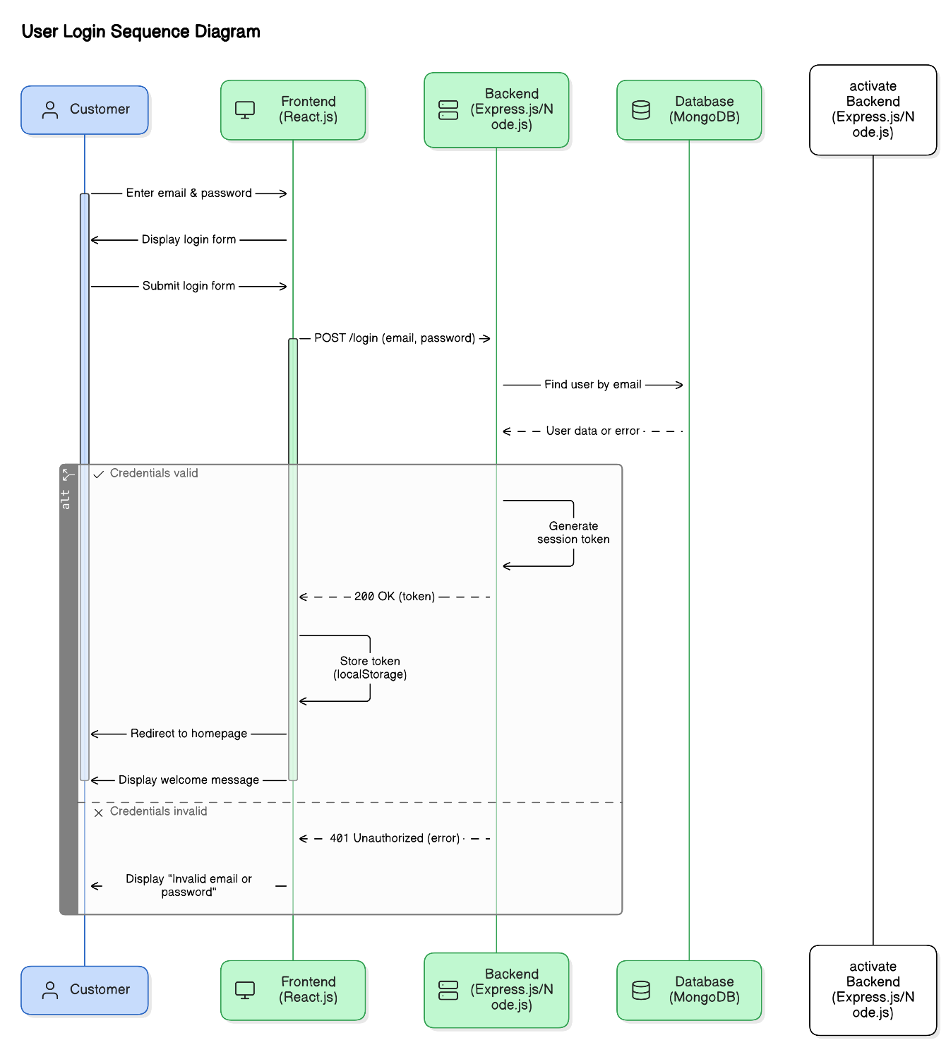

Add Product to Cart
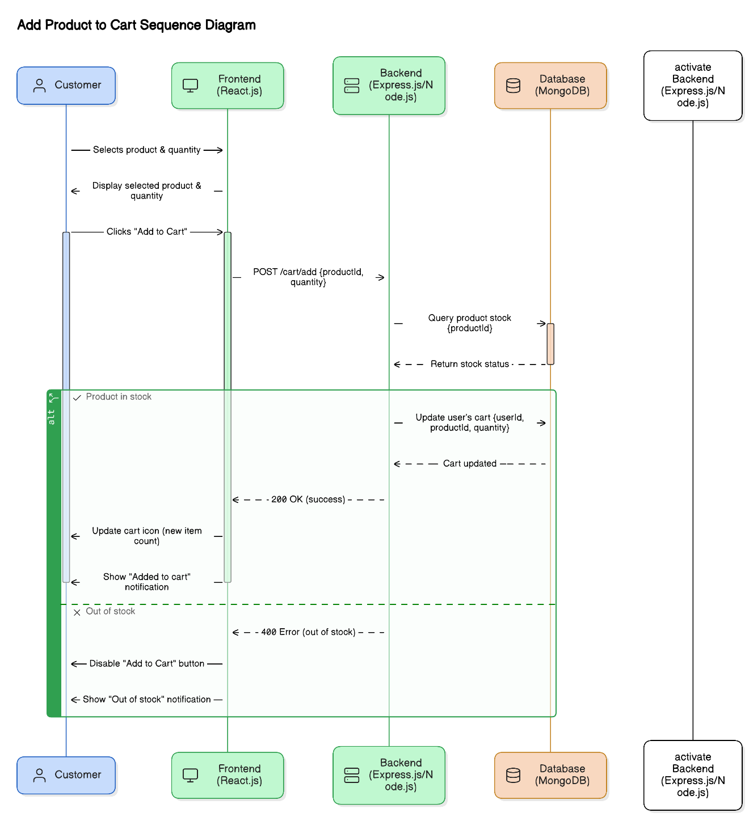

Checkout Process
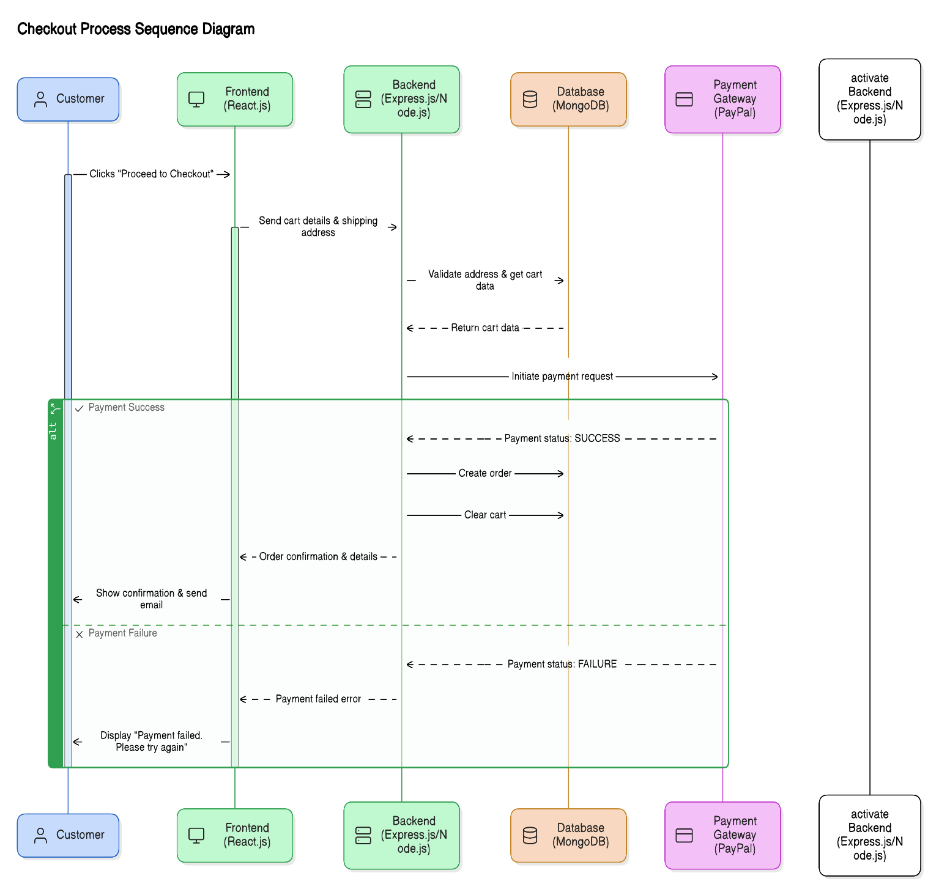

Admin Add Product to Platform

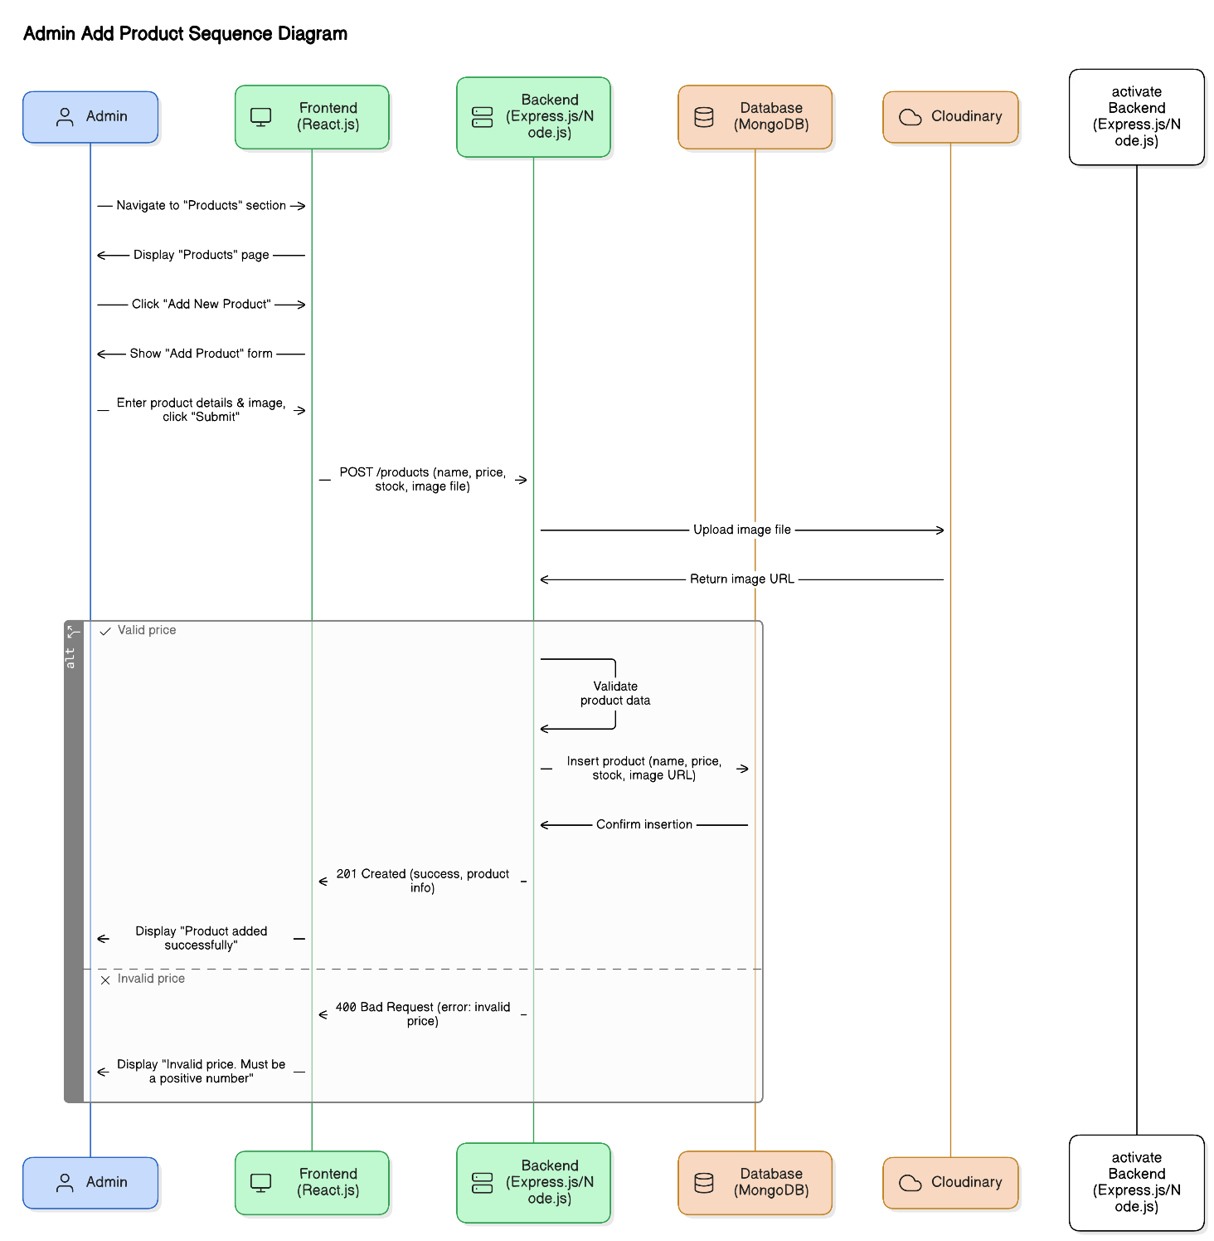

State Diagram

User Registration
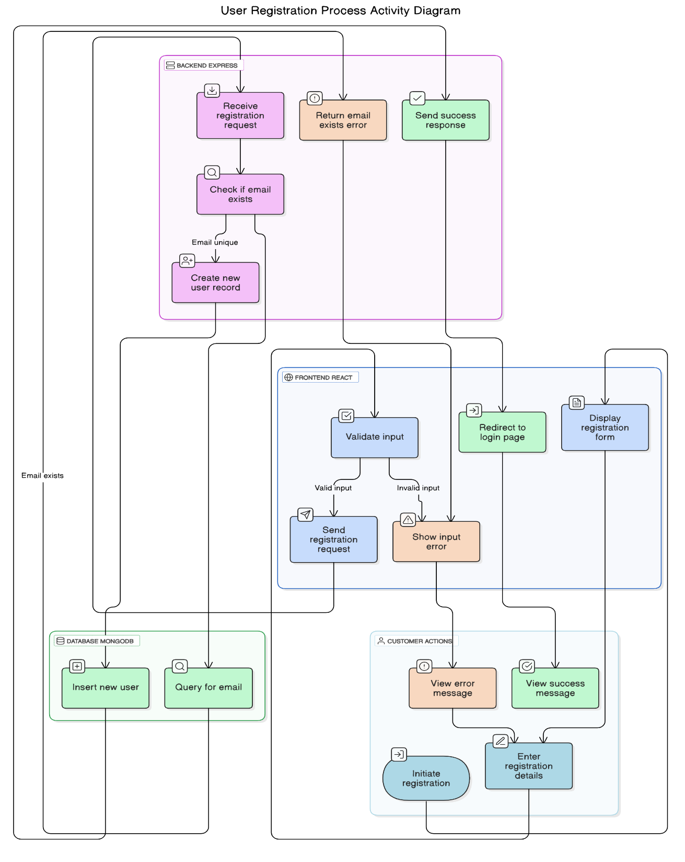

Add Product to Cart
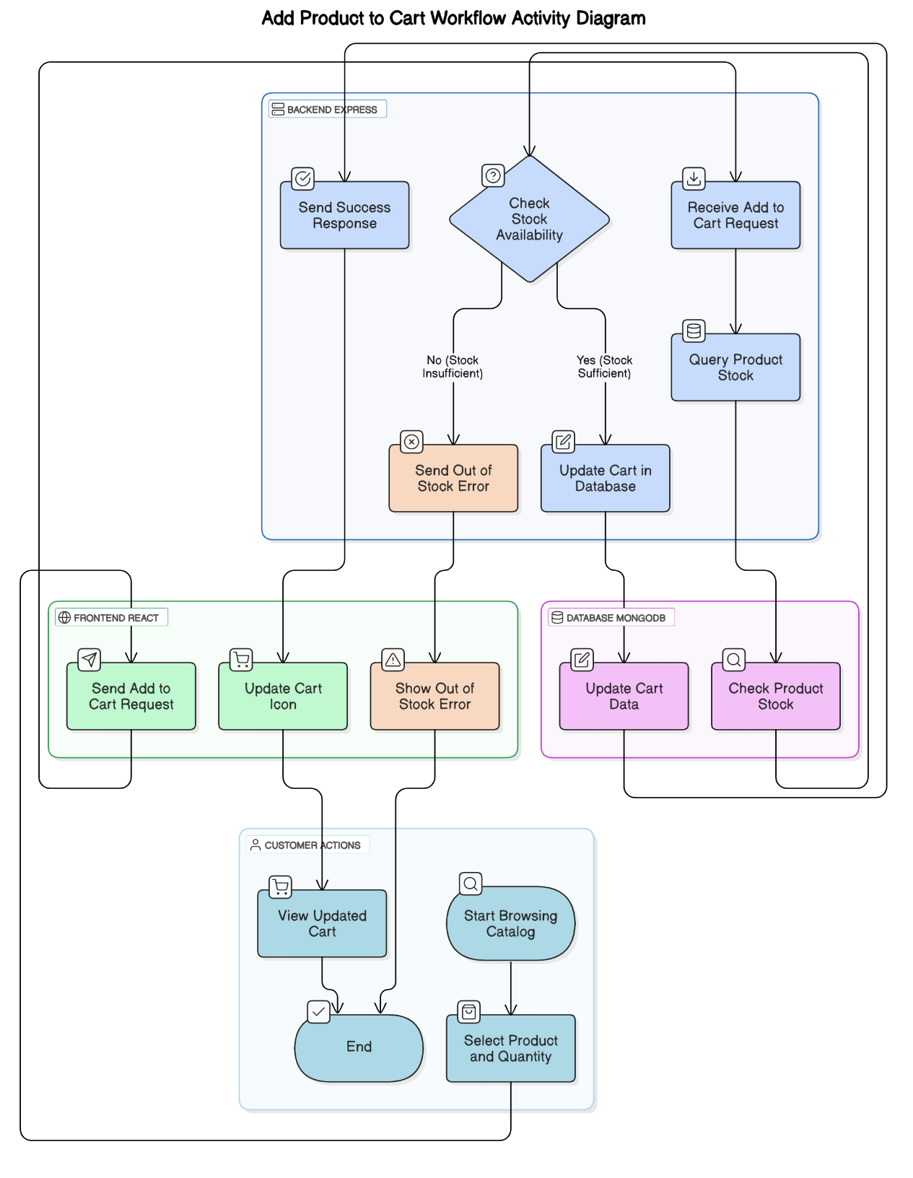

Checkout Process
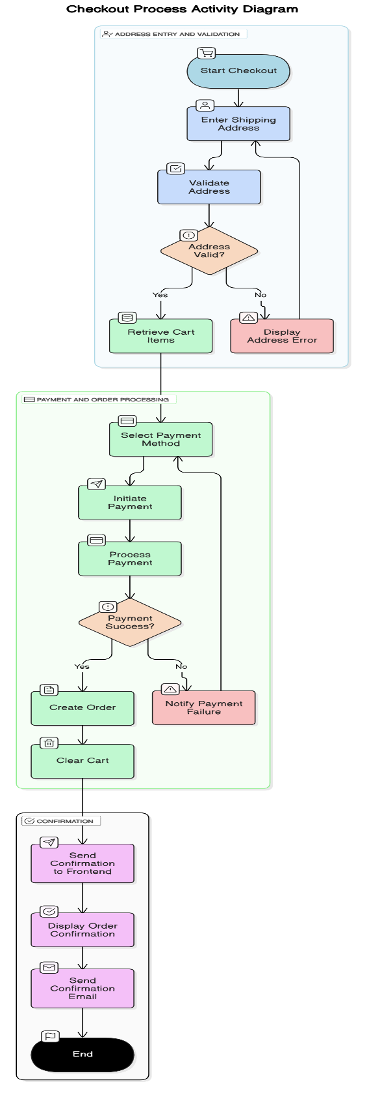

Admin Add Product
